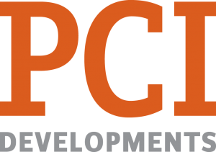
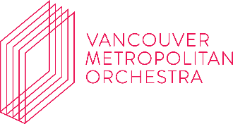

VANCOUVER METROPOLITAN ORCHESTRA 2022-2023 EDUCATIONAL OUTREACH PROGRAMME
REGISTRATION FORM

Name of School: Click or tap here to enter text.
School District: Click or tap here to enter text.

Name of Contact: Click or tap here to enter text.

Contact Number Click or tap here to enter text.

Contact Email: Click or tap here to enter text.

Programme Selection (Please refer to programme booklet for detailed info:
☐ PROGRAMME 1: Intro to Orchestral Instruments, What to listen to, and Conduct Us!
☐ PROGRAMME 2: Looking into the Band (featuring a Wind Sextet)
☐ PROGRAMME 3: VMO Conductor in Workshop with School Ensembles
☐ PROGRAMME 4: VMO Musician in Workshop for Sectional practices or Demonstration
Preferred Dates / Times (Please select all that apply)
☐ MONDAY MORNING | ☐ TUESDAY MORNING | ☐ WEDNESDAY MORNING | ☐ THURSDAY MORNING | ☐ FRIDAY MORNING
☐ MONDAY  AFTERNOON | ☐ TUESDAY AFTERNOON | ☐ WEDNESDAY AFTERNOON | ☐ THURSDAY AFTERNOON | ☐ FRIDAY AFTERNOON

Special Notes / Requests:
Click or tap here to enter text.

